**Stage 1: The login system**

**Setting up the database;**

I used my SQL word bench to create the database ‘loginsystem’ and it contains 2 items; the primary key username and password. This will allow me to store the username and password of all the users.

This is the SQL statement I used to insert some initial values.

I inserted these values into the database.

And this is how the database looked after i inserted these values.

**Connecting to the database;**

This will create an automatic connection to the database and it will allow me to use it throughout the program.

This proves that the connection I made is correct as it prints all the contend in the database.****

**This is the first location so adjusting the size and location we get;**

**Iteration 3 (adding a signup button)**

**Iteration 4 (cleaning up and making it compatible with the whole program)**

**Iteration 1 Login_button module**

**Iteration 2**

**Iteration 1 (Sign up button)**

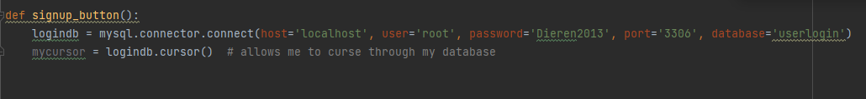

**Iteration 2**

**Iteration 3**

**Iteration 4**

**Iteration 5**

**Validation**

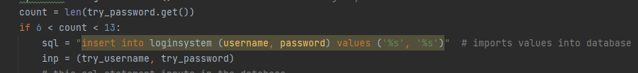

**Testing**

